Guideline to compose a full Paper
(headline in 1 or 2 lines, font Arial 18pt in bold)
First author *, second author, (coauthor is specified by *, font Times New Roman 12pt in bold).

- Title and a short address of first author, e-mail address (Times New Roman 10pt)
- Title and a short address of second author, e-mail address (Times New Roman 10pt)

Abstract (Times New Roman 14pt in Bold)
Each paper should include an Abstract that has been composed between 120 and 300 words in one paragraph including left and right margins, which should be 35 mm from the edges of the paper. This section should independently explain the subject, aims, research method and a summary of the article 's results. However, it is not considered as a preface. Mentioning the references must be avoided in this section.
The font to this section is (Times New Roman 11pt).
The position of the title in this section is 120 mm from the top of the page or upper edge.

Key words: minimum 4 and maximum 6 words which are separated by commas and placed in one line. (Times New Roman 11pt)

1. Introduction (Times New Roman 14pt in Bold)
This guideline has been composed for author's use according to the standard methods of this conference. Compliance with these standards is mandatory for all authors. Please note that this document has been prepared in compliance with the mentioned regulations and can be used as a sample after removal of symptoms and descriptions of additional guidance.
Writing papers requires word 2003 software in windows XP, and A4 paper is needed. In preparing the main text consider using the (Times New Roman 12pt) font and single line spacing.
The text of the paper should be provided with margins of 35 mm from the upper edge and 25 mm from the bottom, right, and left edges.
The title of each section uses the font (Times New Roman 14pt in Bold) with the number of sections, and as pacing with a blank line, from the previous section. The subtitles should be written with the font (Times New Roman 12pt in Bold), with the same order.
The first line of all paragraphs should be indented 6 mm.
Punctuations like dots, commas, etc. must be properly used.

2.Submission
All full papers will be evaluated by the juries of conference. For this reason, it is necessary to the text file to be prepared according to the terms of this document and submitted with the doc and pdf format via conference's user’s system in the website.
Secretariat excuses submissions that are not provided with these formats. Do not submit files with other extensions such as docx.
In case of facing with any problem while submitting share with the secretariat of the conference via the address info@icimah.com
The state of acceptance of the paper will be informed to the co-author which has recently been specified with an asterisk in the list of authors. However, the status of articles can be followed via the website of the congress. Error! Hyperlink reference not valid.
In case of acceptance it's necessary to the authors, to do the required corrections asked by juries in a limited time and submitting the final version via the conference's website.

3.The maximum length of the paper
The maximum number of pages which contain the text of the article and all of its components such as figures and tables are 14 pages.

4. Mathematical Equations, figures, and tables
1-4- Mathematical Equations
All the Mathematical Equations should be written in the middle of the line according to the Latin font of the text. To write the names of variables either in the Mathematical Equations or the text, italicize text's mode. Mention each link's number in the sequence form between parentheses and right furthermost.
For instance, pay attention to the following formula:
Where vto is mortar shear stress, vtest is the force required to remove the bricks, Oc is the stress of gravity load at the testing area and Ab is the sum of two surfaces of brick at the top and bottom horizontal seams.

2-4- figures and tables
All figures and tables should be included in the text and the closest place to the first project in the context. Figures and tables will be placed in the middle of the lines.
Figures must have sufficient quality and be clear. Letters, signs and titles must be legible and chosen in a size that is separable and selected. If you are including tables, It is essential to identify the quantity and unit of each axis in the figure. Each figure or table contains a sequence number which is independent and has to be mentioned inside the text. Also each figure or table contains an independent title which should be written below or above the table with the font (Times New Roman 11pt in Bold).
If the figure or table of the research is not ready yet, and if it is taken from a specific reference, the number of reference has to be mentioned in brackets at the bottom of the figure or the table.
A blank line above and below each figure or table is necessary to separate it from the text. For instance, see table 1 and figure 1:

Table 1: a sample of a table
number of words | title | number
 | perefac | 1
 | A review to the perevious researchs | 2
 | conclusion | 3

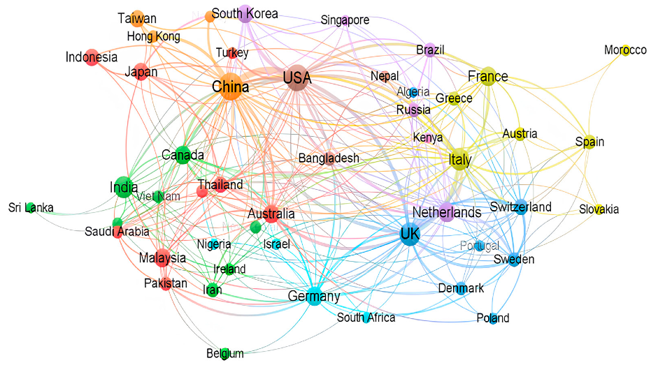
Figure 1 :pic

5. Units
Standard units SI system is the only acceptable system for the scheme of the issues.
Under special conditions where the scheme of the issues in other systems are essential, it is necessary to list the equivalent of these standard SIs. Note that the units for the amounts listed in tables and axes titles in shapes should not be forgotten.

6. Subtitle
In case of using subtitles use the font (Times New Roman 11pt).

7. Acknowledgments
Each Paper should be provided with a summary of the research results presented in the article at the end of the context. Possible recommendations are also presented in this section.

8. Appreciation
If necessary, a brief appreciation can be mentioned before the list of references.

References
References section, the last part of the paper which is not given a title number, are listed and mentioned according to their sequence in the context.
Mentioning each reference within the text must be provided with the sequence number inside brackets.
Font used for English references will be (Time New Roman 11pt).
After identifying each reference (6pt), a spacing within the next reference is required.
Specifications of each reference have to be complete and standard like samples presented below:

[1] Dicleli M, Bruneau M. Seismic performance of single-span simply supported and continuous slab-on-girder steel highway bridges. Journal of Structural Engineering, ASCE; 121(10): 1497-1506, 1995.
[2] AASHTO. LRFD bridge design specifications (4th ed.). Washington (DC): American Association of State Highway and Transportation Officials; 2007.
[3] Chopra AK. Dynamics of structures: Theory and applications to earthquake engineering (2nd ed.), Prentice Hall, Englewood Cliffs, 2001.
[4] Computers and Structures, Inc. SAP2000, version 7.4, Integrated structural analysis and design software. Berkeley, CA; 2000.

